**THE UNIVERSITY OF MICHIGAN-DEARBORN**

**SCHOOL OF ENGINEERING**

**INDUSTRIAL AND MANUFACTURING SYSTEMS ENGINEERING DEPARTMENT**

**IMSE/CIS 381: INDUSTRIAL ROBOTICS**

**ASSIGNMENT #2**

**1.** Consider a TRL:R manipulator with the following setting (Figure 1)

Length of base link L1 =20.0 in.

Length of extension link L =30.0 in.Length of the wrist, L4 = 4.0 in.

Base angle,    = 15 degrees

Elevation angle  = -20 degrees

Pitch angle,  = -15 degrees

a) Determine the coordinates of the point that can be reached by the end -of-arm

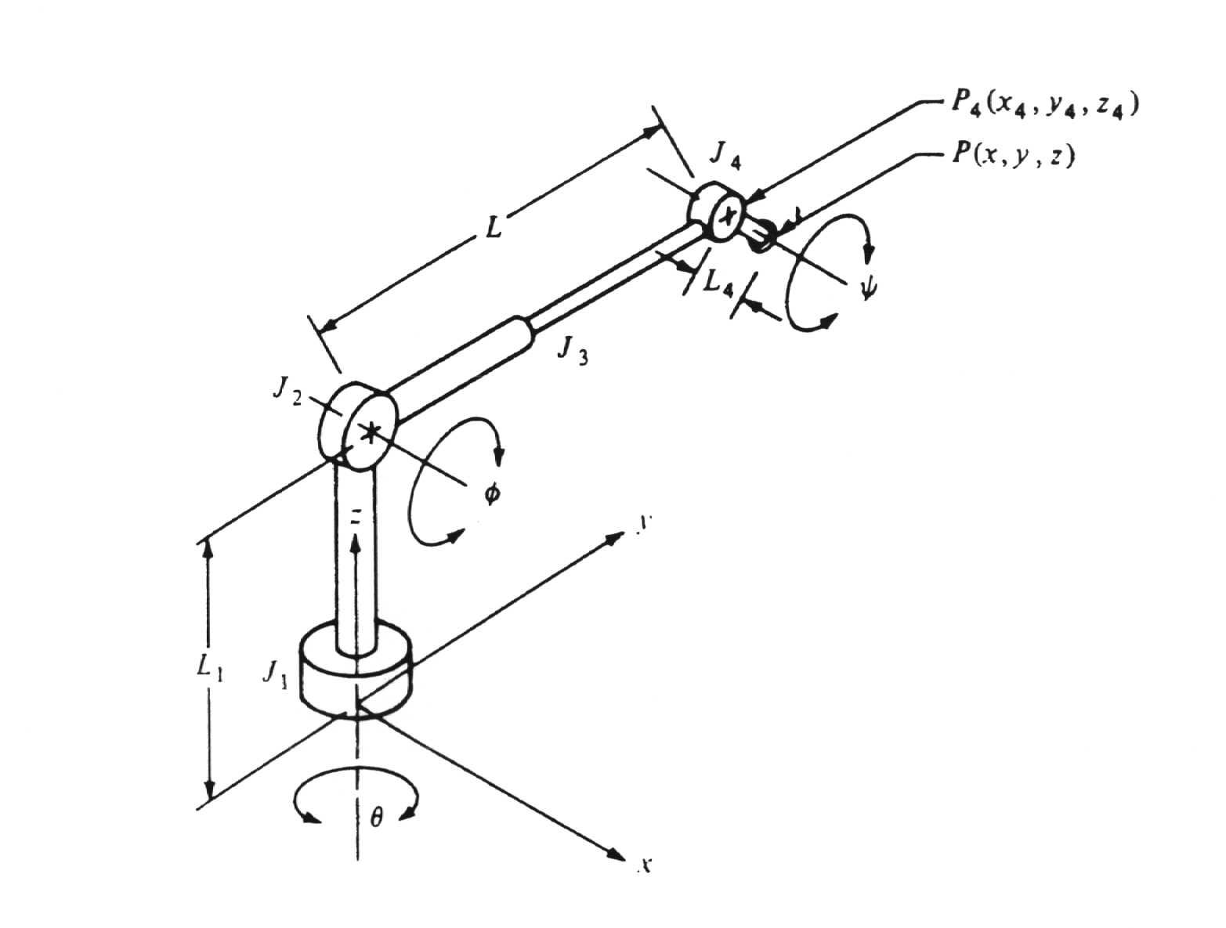

**Figure 1 A 4 d.o.f. Robot in 3D.**

b) Suppose the robot is commanded to move to a new position Pj (  = 30,  = -10,  =15, L= 25), the maximum speed of any rotational joint is 10o/s and the maximum speed for the linear joint is 2.0 in/s. If the robot controller has joint interpolation routine, determine the time and speeds of each joint to move the robot to the new position.

**2.** It is desired to determine the values to which angles θ1 and θ2 must be set in order to achieve a certain point in space for the manipulator shown in Figure 2. The length of Joint 1, L1 = 10 in., the length of joint 2, L2 = 12 in. The point Pw which the robot must achieve is defined by the coordinates x = 12.0 and y = 6.0. Using the reverse transformation methods, determine the angles θ1 and θ2 required to achieve the point in the configuration in Fig. 2.



Figure 2. A 2 d.o.f. robot in 2D

3. A Cartesian coordinate robot with LLL configuration is to move from position A of coordinates (x,y,z) = (25, 10, 10) to point B of coordinates (x, y, z) = ( 5, 30, 20). All coordinates are given in inches. The maximum velocities for the three joints are 8 in./s, 5 in./s, and 10 in./s, respectively.

1. What is the time required to move from point A to B, if the robot controller has slew motion routine?

b. What are motors’ speeds to move from point A to B, if the robot controller has joint interpolation routine?

**4.** The manipulator shown in Figure 3 is at current position Pw (x=17.2 in, y=10.00 in., Ψ= -60o). It was commanded to move to a new position Pj ( Θ1 =110o, Θ2 = -80o, Θ3= -20o). The length of link 1, L 1= 12 in., the length of link 2, L2=10 in., the length of link 3, L3=3 in. The three joints are driven with motors which have a maximum joint speeds of 30 degrees/sec.

a. Determine the time to carry out this movement if the robot has joint interpolation capability.

b. Determine the coordinates (x,y) of the tip of link 3 at the end of the move.

**y**

**J2**

**L2**

**L1 J3**

**L3  60o**

**J1**

**x**

Figure 3 Three d.o.f. robot in 2 D

5. Consider the following transformation of a coordinate frame (CF):

“Translate 3 along X, then Rotate 45o about Z,”

(a) Find the transformation matrix for the above transformation

(b) Identify the position of the origin of the new frame after the transformation with respect to the original coordinate frame

(c) Find the old frame coordinate of (1,1,1) in the new frame

(d) Find the inverse matrix for the transformation